ARGYLL BIRD CLUB Membership Application Form
Scottish Charity number SC050823 www.argyllbirdclub.org
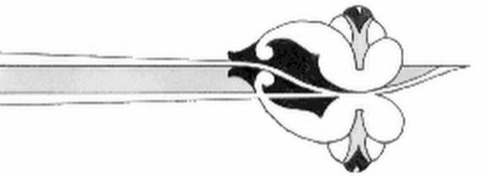
To apply for membership, please complete this form and email to
Rachel Harris, Membership Secretary membership@argyllbirdclub.org
Alternatively post it to:
Rachel Harris, Membership Secretary, Argyll Bird Club, Beech Hill, Inverneill, Lochgilphead, PA30 8ES Tel: 01546606186

I/we wish to apply for membership of the Argyll Bird Club

Title: | Forenames: |  | Surname:
Address:

Post Code: |  | Date:
Telephone Number(s)
E-mail:

Annual subscription (please put X in box)
Ordinary £10 [ ] Family/Joint £15 [ ]
Corporate £25 [ ] Junior (25 and under)free [ ]

[ ] I want Gift Aid on my donation and on any donations, I make in the future or have made in the past 4 years.
Please notify the Membership Secretary if you:
- want to cancel this declaration
- change your name or home address
- no longer pay sufficient tax on your income and/or capital gains

Our preferred subscription payment method is a direct debit through our bank account:
Bank of Scotland – Argyll Bird Club – 80-22-60 - 21843268

Or you can set up a direct debit to pay your subscription by following this link: https://pay.gocardless.com/BRT0002NHGCGHK5
The Direct Debit Guarantee 
- The Guarantee is offered by all banks and building societies that accept instructions to pay Direct Debits
- If there are any changes to the amount, date or frequency of your Direct Debit the Argyll Bird Club will notify you at least 10 working days in advance of your account being debited or as otherwise agreed. If you request the Argyll Bird Club to collect a payment, confirmation of the amount and date will be given to you at the time of the request
- If an error is made in the payment of your Direct Debit, by the Argyll Bird Club or your bank or building society, you are entitled to a full and immediate refund of the amount paid from your bank or building society
- If you receive a refund you are not entitled to, you must pay it back when the Argyll Bird Club asks you to
- You can cancel a Direct Debit at any time by simply contacting your bank or building society.
Written confirmation may be required. Please also notify the Argyll Bird Club.
* Your personal data held by the Club is held for the explicit purpose of providing membership services and will not be shared with any other organisation.

