**ARGYLL BIRD CLUB**

[www.argyllbirdclub.org](http://www.argyllbirdclub.org)

Scottish Charity number SC050823

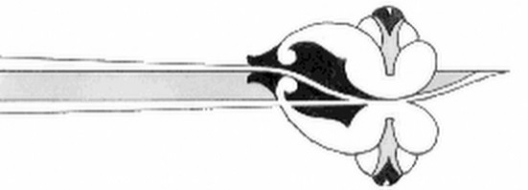

To apply for Gift Aid, please complete this form and email to

David Harris, Treasurer [treasurer@argyllbirdclub.org](mailto:treasurer@argyllbirdclub.org)

Alternatively post it to:

David Harris, Treasurer, Argyll Bird Club, Beech Hill, Inverneill, Lochgilphead, PA30 8ES Tel: 07974430001

**Gift Aid Declaration**

**Name of charity: Argyll Bird Club Charity number SC050823**

Details of donor:

|  |  |  |
| --- | --- | --- |
| Title: | Forenames: | Surname: |
| Address: | | |
| Post Code: | | |

I certify that I pay Income Tax or Capital Gains Tax within the UK to at least equal to the basic rate of Tax. I understand that if I pay less Income Tax and/or Capital Gains Tax than the amount of Gift Aid claimed on all my donations in that tax year it is my responsibility to pay any difference.

I want the charity to treat all annual membership subscriptions that I have made in the past 4 years and all future subscriptions from the date of this declaration as Gift Aid donations until I notify you otherwise.

|  |  |
| --- | --- |
| Signature: | Date: |

Notes:

* You can cancel this declaration at any time by notifying the Treasurer, Argyll Bird Club.
* If in the future your circumstances change and you no longer pay tax on your income or capital gains equal to the tax that the charity reclaims, you can cancel your declaration.
* If you pay tax at the higher rate, you can claim further tax relief in your self-assessment tax return.
* If you are unsure whether you qualify for Gift Aid tax relief, ask Argyll Bird Club for guidance.
* Please notify the Treasurer, Argyll Bird Club if you change your name or address.