ARGYLL BIRD CLUB Membership Application Form
www.argyllbirdclub.org
Scottish Charity number SC050823
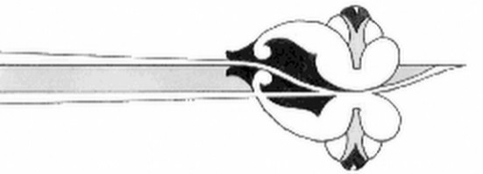
To apply for membership, please complete this form and send it to:
Dorothy Hogbin, Membership Secretary, South Craleckan, Furnace, Inveraray, Argyll, PA32 8XN
Tel: 01499 500665 eMail: membership@argyllbirdclub.org

I/we wish to apply for membership of the Argyll Bird Club

Name(s) *___________________________________________________________________

Address: ___________________________________________________________________

___________________________________________________________________________

Post Code: ______________________

Telephone number(s) ________________________________________________________

e-mail: _____________________________________________________________________

Annual subscription (please put X in box)
Ordinary £10 [ ] Family £15 [ ]
Corporate £25 [ ] Junior (25 and under) free [ ]

[ ] I want Gift Aid on my donation and on any donations I make in the future or have made in the past 4 years.

You can set up a direct debit to pay your subscription
by following this link: https://pay.gocardless.com/AL0004JDP4XJ5J
or you can send a cheque with this form.
Subscriptions paid after 30th September will include membership for the following calendar year, otherwise renewals are due on 1st January each year.
The Direct Debit Guarantee
- The Guarantee is offered by all banks and building societies that accept instructions to pay Direct Debits
- If there are any changes to the amount, date or frequency of your Direct Debit the Argyll Bird Club will notify you at least 10 working days in advance of your account being debited or as otherwise agreed. If you request the Argyll Bird Club to collect a payment, confirmation of the amount and date will be given to you at the time of the request
- If an error is made in the payment of your Direct Debit, by the Argyll Bird Club or your bank or building society, you are entitled to a full and immediate refund of the amount paid from your bank or building society
- If you receive a refund you are not entitled to, you must pay it back when the Argyll Bird Club asks you to
- You can cancel a Direct Debit at any time by simply contacting your bank or building society.
Written confirmation may be required. Please also notify the Argyll Bird Club.

* Your personal data held by the Club is held for the explicit purpose of providing membership services and will not be shared with any other organisation.

