ARGYLL BIRD CLUB Membership Application Form
www.argyllbirdclub.org
Scottish Charity number SC050823
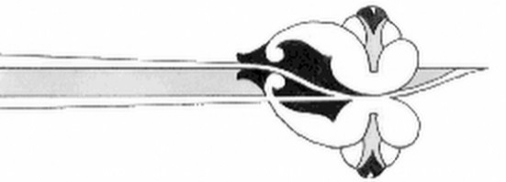
To apply for membership,
please complete this form and send it to the Membership Secretary
Dorothy Hogbin, South Craleckan, Furnace, Inveraray, Argyll, PA32 8XN
Tel: 01499 500665 eMail: membership@argyllbirdclub.org

I/we wish to apply for membership of the Argyll Bird Club

Name(s) *___________________________________________________________________

Address: ___________________________________________________________________

___________________________________________________________________________

Post Code: ______________________

Telephone number(s) ________________________________________________________

e-mail: _____________________________________________________________________

Please pay your subscription by bank transfer to Argyll Bird Club
Sort code 80 22 60 account number 21843268
or by cheque payable to Argyll Bird Club and post to the above address

Subscriptions paid after 30th September will include membership for the following calendar year, otherwise renewals are due on 1st January each year.

Annual subscription (please put X in box)

Ordinary £10 [ ]
Family £15 [ ]
Corporate £25 [ ]
Junior (25 and under) free

* Your personal data held by the Club is held for the explicit purpose of providing membership services and will not be shared with any other organisation.

