ARGYLL BIRD CLUB Membership Application Form
www.argyllbirdclub.org
Scottish Charity number SC008782
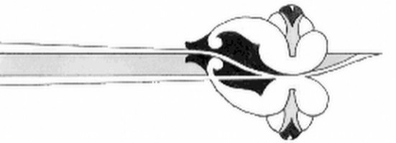
To apply for membership,
please complete this form and send it to the Membership Secretary
Dorothy Hogbin, South Craleckan, Furnace, Inveraray, Argyll, PA32 8XN
Tel: 01499 500665 eMail: membership@argyllbirdclub.org

I/we wish to apply for membership of the Argyll Bird Club

Name(s) ___________________________________________________________________

Address: ___________________________________________________________________

___________________________________________________________________________

Post Code: ______________________

Telephone number(s) ________________________________________________________

e-mail: _____________________________________________________________________

How would you like to receive The Eider (quarterly newsletter)?
You can tick both boxes, but the e-mail only option save the club production and postage costs.

Post (black & white version)[ ] e-mail (colour version, PDF file)[ ]

Please pay by bank transfer to Argyll Bird Club
Sort code 80-08-86 account number 00121406
or by cheque payable to Argyll Bird Club and post to the above address
or by standing order – please complete the form and return to the Membership Secretary

Annual subscription (please tick box)

Ordinary £10 [ ]
Junior (25 and under) free
Family £15 [ ]
Corporate £25 [ ]

ARGYLL BIRD CLUB
www.argyllbirdclub.org
Scottish Charity number SC008782

Standing Order

Bank name: ______________________________________________________________

Bank address: _____________________________________________________________

Post code: __________________

Sort code: _____________________ Your account number _____________________

Please pay to the Bank of Scotland Sort code 80 08 86
to the account of Argyll Bird Club number 00121406
the sum of £ now and then annually on the first of January each year until further notice

Please cancel any previous standing orders in favour of Argyll Bird Club

Signature: ______________________________________ Date:____________________

Your name: _______________________________ (use my name as reference)

Please complete this form and send it to the Membership Secretary, Argyll Bird Club
Dorothy Hogbin, South Craleckan, Furnace, Inveraray, Argyll, PA32 8XN

