ARGYLL BIRD CLUB
www.argyllbirdclub.org
Scottish Charity number SC008782
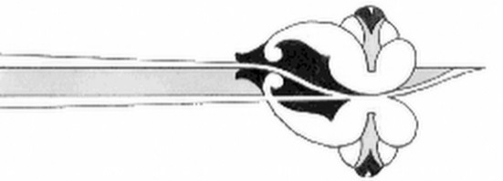
Please return this form, when completed, to:
Peter Hogbin,
South Craleckan,
Furnace,
Inveraray,
Argyll, PA32 8XN eMail: treasurer@argyllbirdclub.org

Gift Aid Declaration

Name of charity: Argyll Bird Club Charity number SC008782

Details of donor:

Title_______ Forename(s)_______________________ Surname______________________

Home address: ______________________________________________________________

___________________________________________________________________________

Post Code: ______________________

I certify that I pay Income Tax or Capital Gains Tax within the UK to at least equal to the basic rate of Tax.

I want the charity to treat all annual membership subscriptions that I have made in the past 6 years and all future subscriptions from the date of this declaration as Gift Aid donations until I notify you otherwise.

Signature: __________________________________ Date: _________________________

Notes:
You can cancel this declaration at any time by notifying the Argyll Bird Club.
If in the future your circumstances change and you no longer pay tax on your income or capital gains equal to the tax that the charity reclaims, you can cancel your declaration.
If you pay tax at the higher rate, you can claim further tax relief in your self assessment tax return.
If you are unsure whether you qualify for Gift Aid tax relief, ask Argyll Bird Club for guidance.

Please notify Argyll bird Club if you change your name or address.

