Friday 20th July

(1pm – 5pm)

Kilmartin Museum
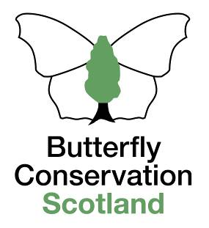

Forester Moth - Caterpillar Challenge
Small Dark Yellow Underwing
.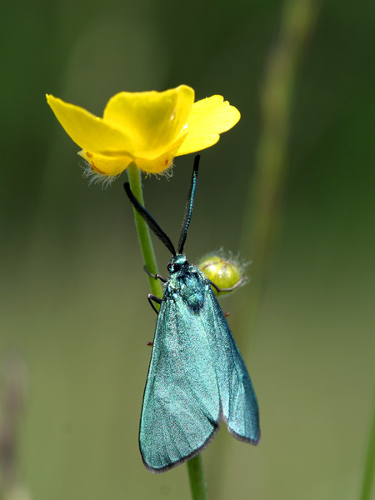
Argyll is a key location in the UK for the rare day-flying Forester moth. However, its caterpillars have never been found in the wild in Scotland.
After a brief indoor session we will visit a nearby site to look for them and their feeding signs to help better understand their preferred haunts.

The day is free, informal, informative & fun!

Everyone welcome

No previous knowledge required

For more information and to book a place please contact
Tom Prescott; Email: tprescott@butterfly-conservation.org
Mobile: 07979 785665

