Argyll Bird Report

Volume 21
with Systematic List for the years

2006 – 2007

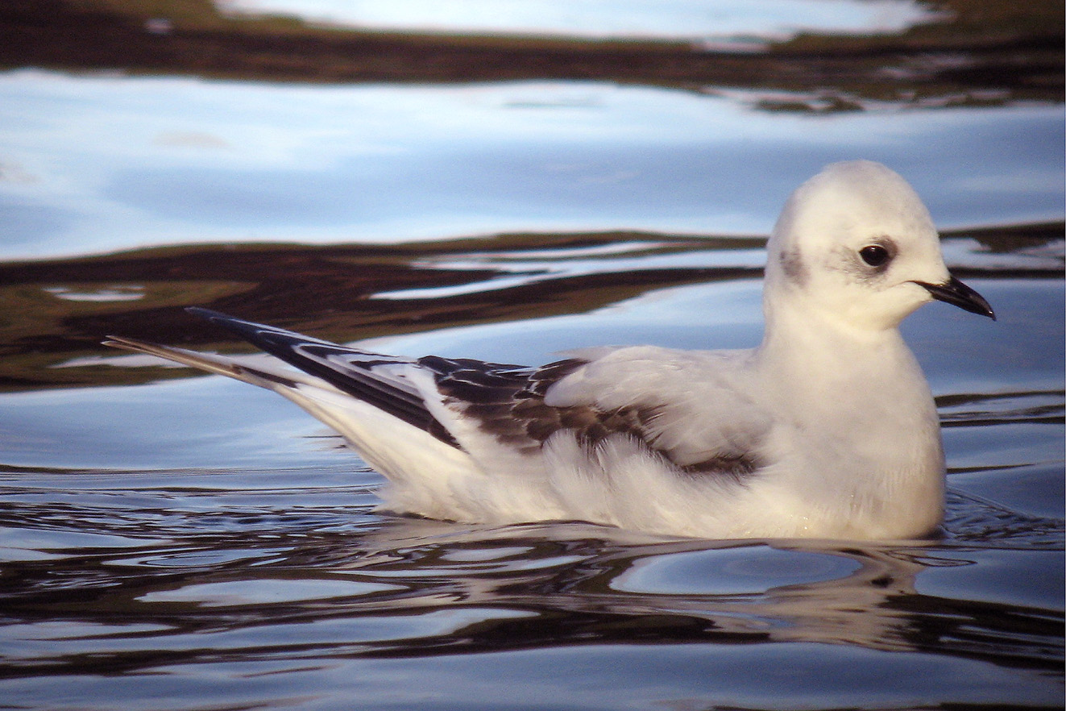
Ross’s Gull – Dec 2006 Jim Dickson

Argyll Bird Club 2010

